SERVICES TO YOUTH ACCOMPLISHMENTS

- 3 STY Link Sisters through Gaston Literacy Council’s Reading Soul Mates Program, volunteer at different Elementary Schools to read with students with low reading skills, so that they can catch up with their fellow students by the end of the school year. STY donated funds to the Reading Soulmates program to enable them to purchase individual books to 301 students in the program. STY is working to install a little free library in one of the schools furnished with books from African American authors that are age appropriate.

- Through the Links Love HBCUs program of STY, the Piedmont (NC) Chapter of the Links, Incorporated participated as Sponsors, and made the Top Teams category in the UNCF 2025 Charlotte Walk for Education. The UNCF and HBCUs together worked to maintain and support a steady flow of graduates who will become a generation of professionals.

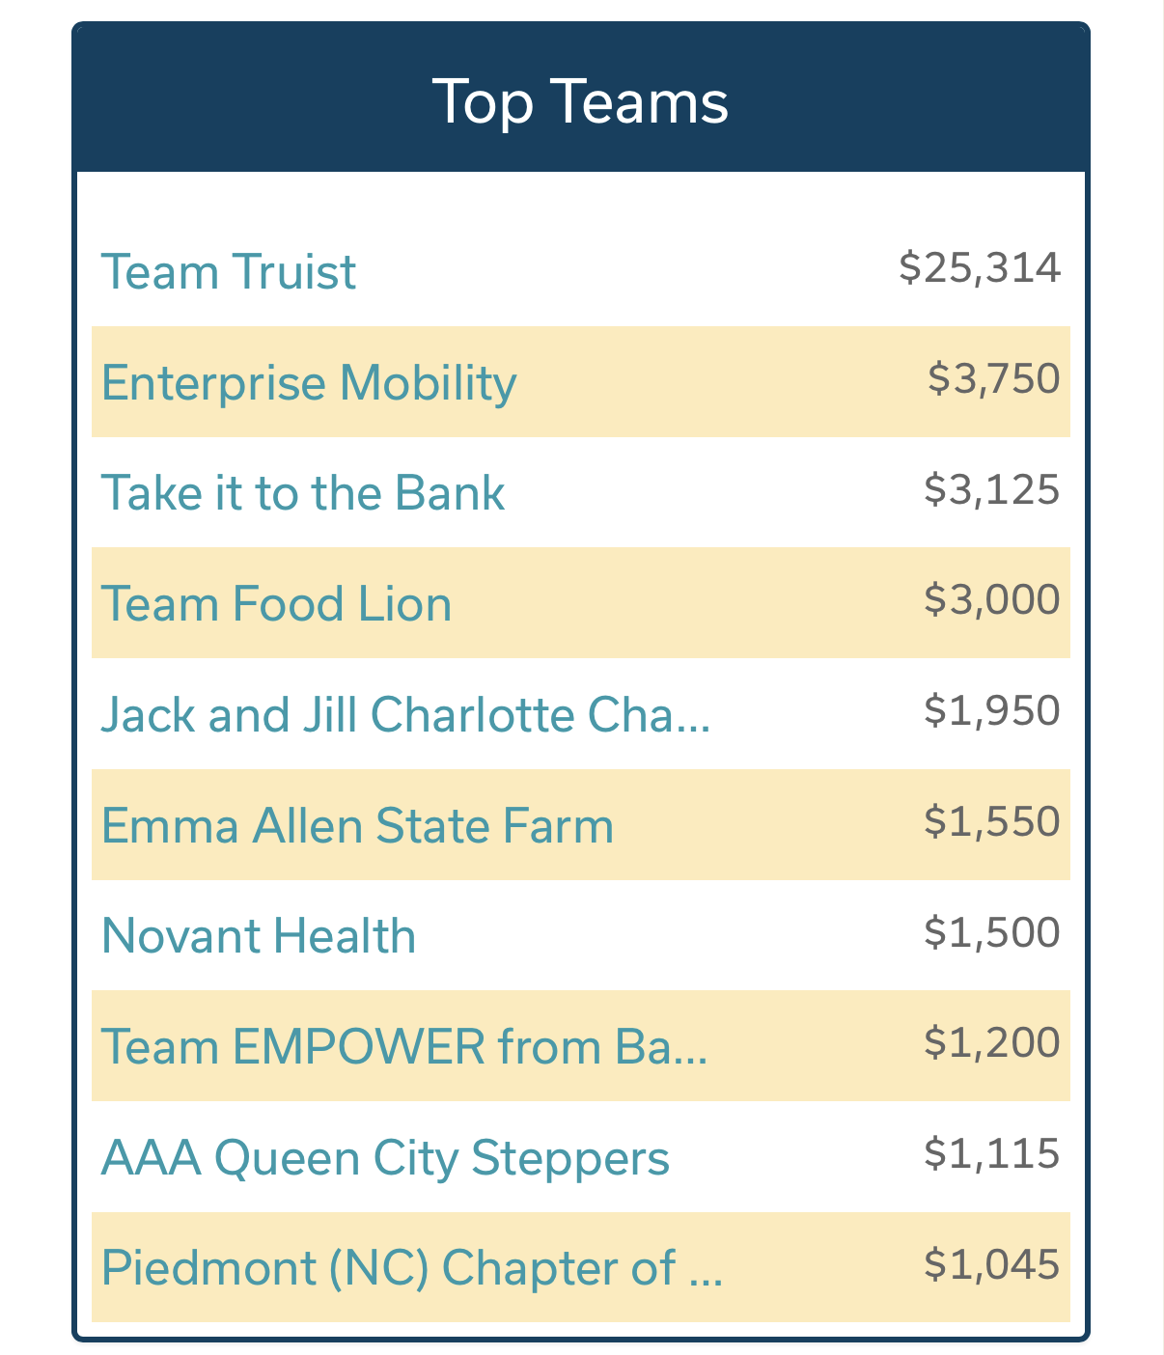

- With the STY Links Love HBCUs Initiative, College Prep and Planning-HBCUs Focus was provided to the Boys and Girls Clubs of Greater Gaston monthly with different presenters.
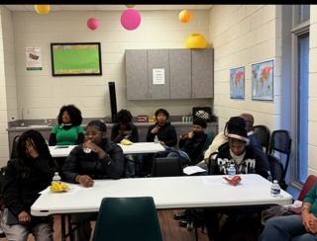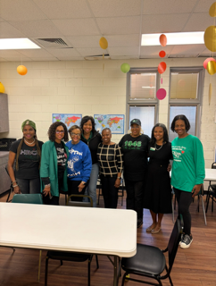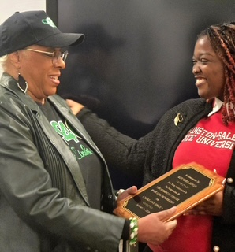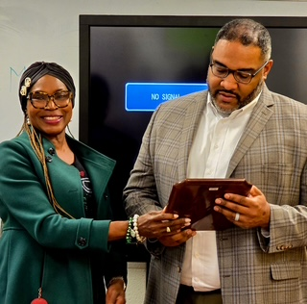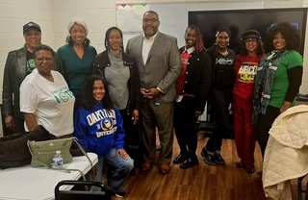

The S.T.E.A.M SHOWCASE was the first partnership event with Piedmont (NC) Chapter of the Links, Incorporated and Gastonia Jack and Jill. Incorporated.

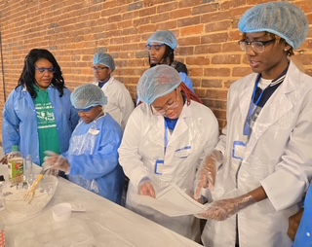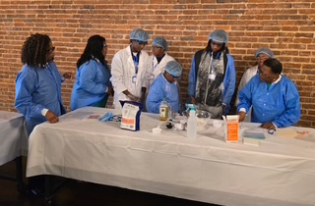

STY presented the LIFE Umbrella Global Awareness program.
Link Robin took it to another level. She had great presenters and great food items representing the different countries featured. Link Robin also served Chick Fil A sandwiches. She had detailed decorations and props! She provided a customs security uniform for Link Lisa Sido to wear and interview all the students with passports coming into the country. It was nothing but excellence all around. Thanks a million Link Robin!

